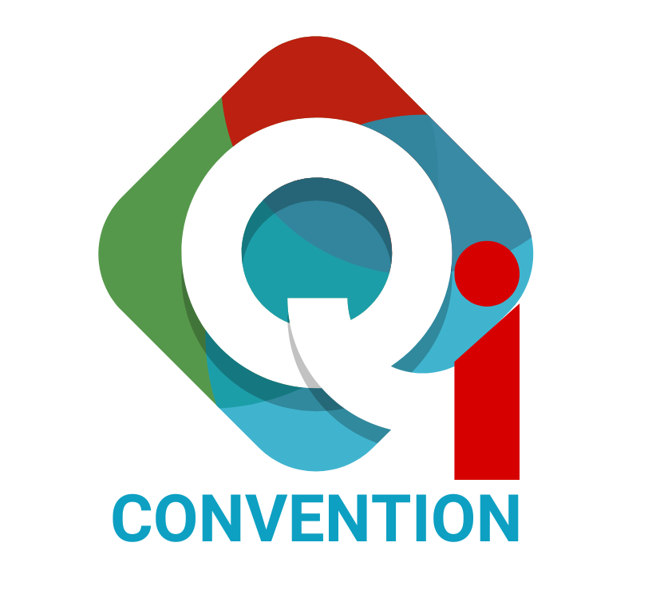

Bangladesh Quality Improvement Convention 2026

Speaker Proposal Submission Form

Please download this word document to fill out the table with relevant information expressing your interest to speak in the Lightning Talks sessions on specific QI thematic issues. Once filled out, convert it to a PDF and submit through the convention website’s dedicate tab within the deadline.

Note: Please read the instructions carefully before you fill out this submission form.

About the Sessions
These sessions are open for anyone across the healthcare sector and beyond, including clinicians, non-clinicians, patients and carers, voluntary / social sector employees, public or private sector and students. We also welcome first time presenters. We are actively seeking to increase the diversity of our speakers who want to share their practical knowledge and on-the-ground experience in implementing Quality Improvement (QI) interventions. Taking place simultaneously across multiple breakout rooms, these Lightning Talks will deliver maximum practical value for attendees' time by providing concise, hands-on QI solutions from across the country. This will be done in a lecture style; hence, speakers need to complete their presentation within the allocated time.
The intention is to bring together short, high-impact presentations centered around key thematic areas of QI. Designed to deliver maximum practical value, these fast-paced sessions bypass abstract theory and research to focus strictly on real-world, frontline QI interventions that have achieved visible, measurable results.
Each session will feature up to a maximum of three speakers who each have a 10-minute slot to showcase their practical improvement project, sharing what actually worked on the ground, lessons learned, and actionable insights that attendees can replicate in their own healthcare settings. Every session concludes with a moderated Q&A, encouraging interactive dialogue between the delegates and all speakers.

General Instructions
- Abstracts to present in the Lightning Talks session must be submitted online only via the official convention web portal.
- Submission Deadline: 15 November 2026. Late submissions will not be accepted.
- All abstracts must be written in English.
- Please note that the submission of an abstract does not imply or guarantee its acceptance. All abstracts will be subject to a review process by the Abstract Review Committee.

- Thematic Areas
Speakers must select one track from the following:

- Theme 1: Quality Improvement in Mental Health Care services
- Theme 2: Quality Improvement in Maternal and Newborn Health Care (MNH) Services
- Theme 3: Quality Improvement in Managing Non-Communicable Diseases (NCD)
- Theme 4: Quality Improvement in Infrastructure Design to Ensure Patient-Centric Services
- Theme 5: Quality Improvement through Healthcare Innovation or Use of Technology
- Theme 6: Quality Improvement Initiatives to Ensure Occupational Health Safety
4. Submission Process
- All abstracts must be submitted electronically via the convention’s official submission portal within the deadline in PDF format.
- Submissions via email or post will not be accepted.
- Authors must ensure that the abstract is thoroughly proofread before final submission

6. Presentation Format
Speakers can present in any of the following formats following the given PPT Template
- PowerPoint
- Audio-visual e.g. video story
- Photo slides
7. Important Dates
- Abstract Submission Opens : October 1, 2026
- Submission Deadline : November 15, 2026
- Abstract withdrawal Deadline : November 20, 2026
- Notification of Acceptance : Will be notified by the first week of December 2026
- Notification of Non-Acceptance : Will be notified by the first week of December 2026

8. Speaker Privileges
- Complimentary registration is granted only to the primary speaker of an accepted abstract (for both single and team submissions). Team members must complete standard website registration to attend.
- Speakers whose abstracts are not selected are still very welcome to attend the convention as delegates. You may register via the website once submission results are announced.

9. Logistics Support
- All speakers whose abstracts are accepted for session speaking are solely responsible for the design, printing, carrying their own devices, cables/ converters/connectors and transportation of any logistical materials they bring to the convention venue.
- The convention organizers will only provide a PPT template, projector with a screen, HDMI cable, and sound system, and not bear any cost related to preparation.
For any queries related to abstract submission:
Email: syasmin@faulty.ihi.org

Fill out the submission form below:

Use fonts: Arial
Font size: 11 pt

Part One: About your work
Title of session
25 words max
Make it eye-catching as well as descriptive

Session description
150 words max
Give a clear, concise and engaging description of what you will be covering and why delegates should attend

Objective of the session OR expected learning outcome in bullet points
100 words max

Session format  Specify how you want to conduct the session while you are speaking | - PPT  - Video  - Photos  - Mix of the above three
Results and evidence to support the information you are presenting
500 words max
Include a short paragraph with the results from your project, including the following:
- The setting the work takes place in (e.g. hospital, community care facility):
- Problem or Challenge faced:
- Your intervention:
- Results (including data to back up your evidence)
- Conclusion and learning for others

Was ethics approval for any research work obtained (where relevant)? | - Yes  - No  - Not relevant
Have you previously presented this work at any national or international forum or conference?  If yes, please state year and location | - If yes, specify the details:……………  - No
Part Two: Your Details
Name
Designation and Organization name
Geographical area
Mention which districts you are representing from
Bio
150 words max

Email
Mobile number

